Queensland University of Technology
IFN736 – Assignment 3
Guided Reflective Practice Portfolio
Student Name: Your Name
Student Number: Your Student Number
Group Number: Your Group Number
Group Name: Your Group’s Name
Project Name: Your Project’s Name
Submission Date: ??/??/202?

Table of Contents
Introduction 2
Section 1 – Project Management Processes 3
Section 2 – Industry Partner Collaboration 4
Section 3 – Ethical Business Practice Considerations 5
Conclusion 6

Instructions: Update the table above upon completing this document (Right Click->Update Field). Delete all red instruction text before submission. Feel free to adjust the layout, theme and aesthetics of this document to suit your purposes. The following is taken from the assignment CRA:
The document should also contain consistent and deliberate use of various imagery, tables, graphs, screenshots and any relevant supporting personalized content to communicate your reflections more appropriately. It should not just be restricted to paragraphs of text, or (even worse) excessive dot point lists. Doing so will result in your report being viewed as a low effort reflection, particularly in the age of LLMs and generative-AI usage. Having only large blocks of generic text responses will immediately be viewed with scepticism, particularly if they do not engage the questions with your personal and project specific circumstances. As this assessment reflects your individual and your group’s project management practices, something you have been engaged in for weeks, you should have a plethora of relevant data, images and graphs at your disposal to communicate your thoughts and answer the questions more abundantly. This should be specifically relevant when describing project management.
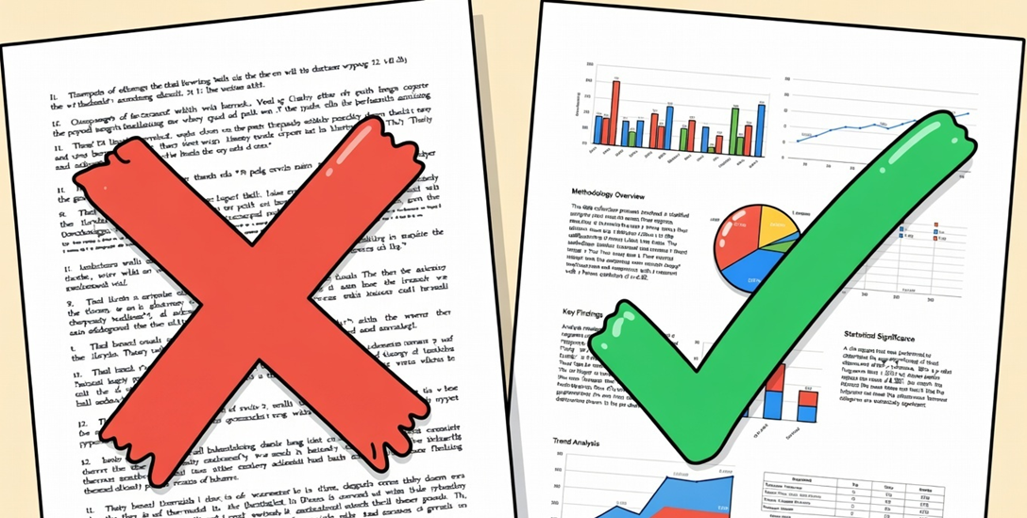
(please delete the above image too)

Introduction
(100-300 words)
Please provide a brief introduction to yourself and your project. Mention what stage you are in your university career, and what stage the project is in at this point in the semester. Please list what kind of work, roles and responsibilities you have taken on over the course of the project, particularly in Phase 2 (i.e. IFN736).

Section 1 – Project Management Processes
(500-1000 words)
Please introduce this section by briefly describing your overall experience working on the project, engaging in Agile Development processes and undertaking SCRUM meetings (or similar) in the last 10 weeks. You should then address the following questions, taken from the CRA:
=====
In this section you will reflect on any new insights or realizations you have made regarding agile development, particularly regarding taking on different roles and the overall general efficiency in the Agile Development process you have employed. This should pertain particularly to the activities, challenges, expectations and artifacts used for Assessment 2 – Work in Progress Meetings. In your discussion, you should aim to directly answer the following 3 questions:

- What were the primary successes and challenges you experienced in adhering to or adapting to the expected agile development practices?

- How did these agile practices influence project velocity, risk management or the delivery of value to your Industry Partner?

- What aspect of the agile development process (if any) has improved the efficiency and workflow of you or your group? Feel free to be very specific here.

You should support your reflection here using concrete examples that you generated and/or utilized for Assessment 2 either individually or as a group, such as burndown information, retrospective discussion points, sprint backlogs etc. You may also opt to generate new artifacts to better communicate these concepts, outside of their use in Assessment 2 and deliberately for this Assessment. Such artifacts will go a long way towards contributing to a higher mark.

=====
For your consideration: Your answers to these questions should be personal and specific to your project – not general responses that could answer any project’s undertaking. As an example, part of your answer(s) may describe your personal experience partaking in SCRUM as the SCRUM Master. This may have created a new appreciation for the role or made you realize it is more than just leading a conversation – there is substantial pre-planning and attention keeping involved. Maybe this means helping out your future SCRUM Masters more in the future, and communicating completed tasks promptly.

Alternatively, your group’s time estimates for certain tasks could have revealed some inefficiency where certain problems were undervalued creating a degree of scope creep as the semester continued. The Agile and SCRUM process allowed you to identify these issues and, overtime, plan accordingly to move the problem tasks towards completion or re-scoping territory.

Section 2 – Industry Partner Collaboration
(500-1000 words)
Please introduce this section by briefly describe how the engagement process and overall relationship with your Industry Partner has progressed over the semester. You should then address the following questions, taken from the CRA:
=====
In this section you will reflect on your ongoing working relationship with your Industry Partner throughout your capstone project, but particularly in Phase 2 (i.e. IFN736). In Phase 2 your group has been given the responsibility of becoming the primary link to your IP which changes the dynamic of communication and feedback slightly. This section therefore focuses on stakeholder management and real-world industry collaboration, a core capstone learning outcome. In your discussion, you should aim to directly answer the following 3 questions:

- How did you manage communication channels, expectations setting, feedback loops and scope changes with your Industry Partner?

- What collaboration strategies proved most (or least) effective, and what would you change if you were to repeat the project?

- Was there anything that impeded progress on the project that was an IP related artifact, requirement or circumstance? How did you and your group work around this?

It is important that you use this section to reflect professionally on your relationship with your industry partner – it is not a section to express disagreements or misunderstandings. You may wish to use evidence of organized meetings, discussions and feedback where appropriate. This is also an appropriate section to detail any other activities (e.g. user testing) you may have facilitated over the course of the semester, either in tutorials, with your industry partner or simply as individuals amongst your peers.

=====
For your consideration: Working with a client or Industry Partner can be one of the most challenging aspects of software development. Sometimes slight miscommunications or misinterpretations of each other’s requirements can snowball and take multiple weeks to rectify. For example, not having access to the database or having a solid understanding of the underlying architecture of some part of the IP’s systems can impede development, seemingly unnecessarily. If you have encountered these kind of problems, this section is the best place to reflect on these kind of development and management issues and how best to tackle them going forward.

Section 3 – Ethical Business Practice Considerations
(500-1000 words)
Please introduce this section by briefly describing any ethical considerations you and your team have had or been required to navigate regarding your project’s development. This section can be longer or shorter depending on the type of project – not all projects will have as serious ethical requirements. You should then address the following question, taken from the CRA:
=====
In the final section of this report, you will reflect on any ethical business-practice issues you encountered (or could have encountered) during your project’s undertaking and within your Industry Partner relationship. You should reflect on how/if the Agile/SCRUM process helped with navigating said circumstances. Ethical considerations may include such topics as data privacy, confidentiality, intellectual property ownership and licensing, conflicts between academic openness and commercial sensitivity or even equitable allocation of tasks amongst team members. In your discussion, you should aim to directly answer the following single question:

- What professional ethical frameworks or organizational policies (if any) guided your decision-making, and what broader lessons will you carry into any future industry roles?

Examples of frameworks and organizational policies include the ACS Code of Ethics, your industry partner’s Company NDA(s) or even QUT’s own research, teaching and development ethics guidelines. While not all the ethical considerations and concepts should necessarily guide your development processes (particularly at university as a student), it is important to recognize how crucial they are when becoming an IT professional.

You should perform some additional research regarding any ethical frameworks and policies to help answer the above question, even if it is not completely relevant to your project and industry partner.

=====
For your consideration: Please do not release sensitive business related, copyright or critical NDA related information regarding your Industry Partner in this section of the assignment.

Conclusion
(100-300 words)
Please use the conclusion to wrap up any other reflections, thoughts or comments that you have regarding your project’s current development processes, specifically as it pertains to project management, industry partner relations and ethical business practices. Anything that does not quite fit the mould of the previous 3 sections may also be introduced here, word count permitting.

